**Civil War Notes**

**Reasons for the War**- The war was a fight over the expansion of slavery. The South believed that limits placed on its expansion would eventually mean the demise of the institution. Northerners wanted to end or diminish the political power of the Southern Planter Class. Both sides believed the black man was inferior to the white.

**Civil War Combat**-

The rifle musket was an evolutionary, not revolutionary, weapon that did NOT make the linear tactics obsolete.

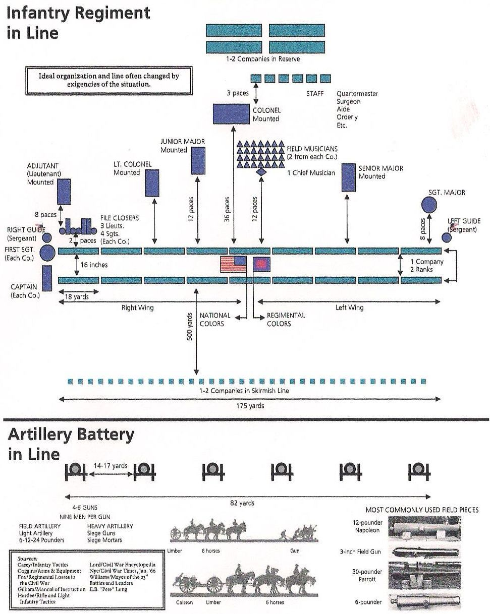

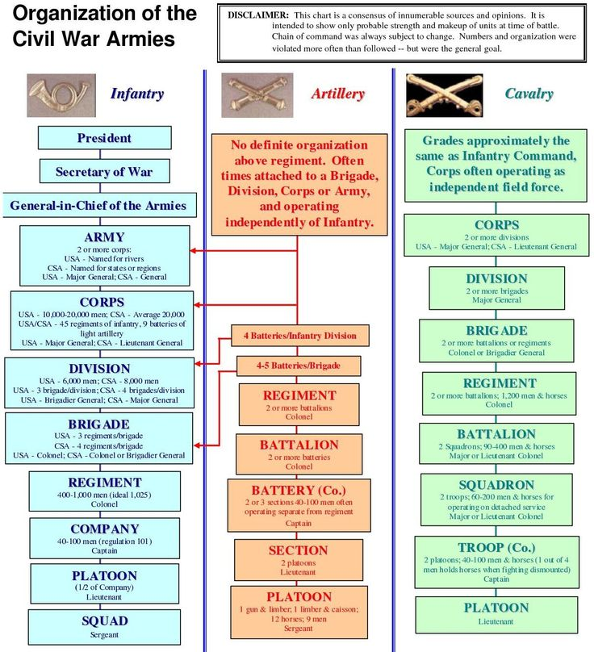

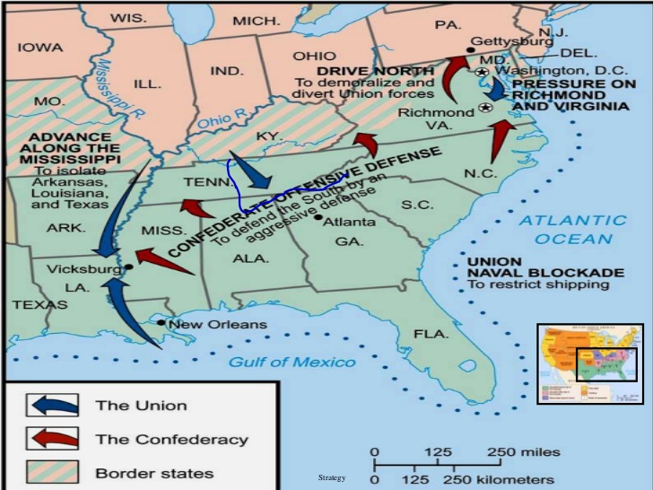

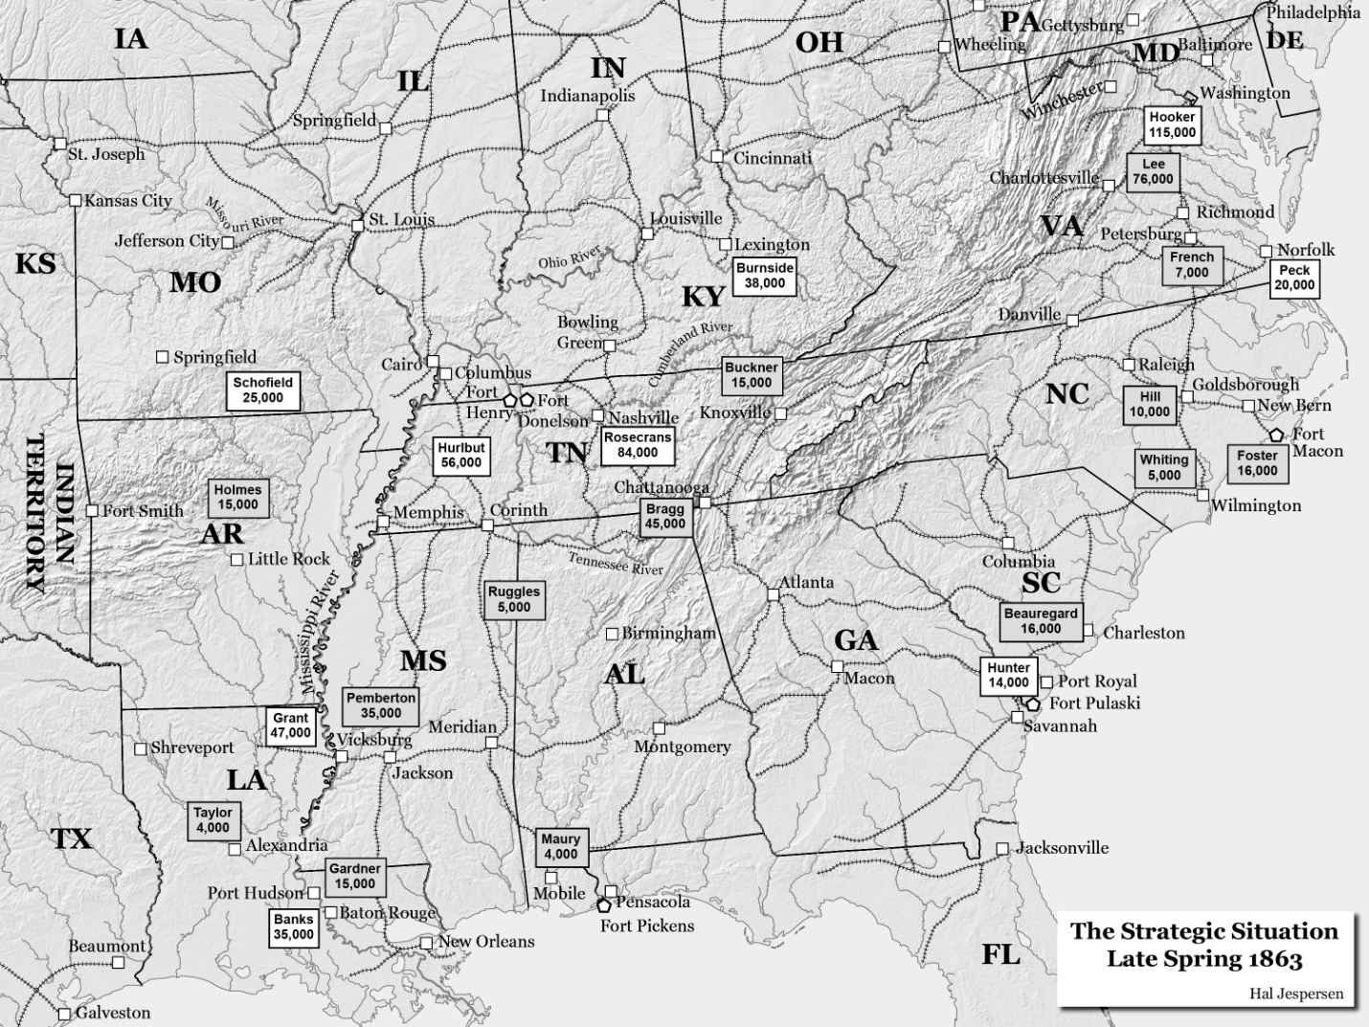

The reasons why Vicksburg was not important.

Overrated as supply hub

* The Confederate Commissary General Lucius Bellinger Northrop stated repeatedly about the difficulties of transferring beeves across the Mississippi in large numbers and the absolute impossibility of them being brought to supply the armies in Virginia and Tennessee, largely because of their emaciated condition in traveling the Texas and Louisiana backcountry.
* *The sources from which beeves in large numbers were to be gotten were Texas and Florida, and complete arrangements were made for securing a supply from both states, and large numbers have been obtained from both, together with a large quantity of pickled beef from Texas. Arrangements were made in 1862-3, to bring cattle from Texas and put them on the grasslands of Virginia and Tennessee, but the long drive [inadequate roads], want of good grass on the way, caused the attempt, which was made with a few droves, to fail.*
* O.R.4, 2, 350-351.
* Lucius Bellinger Northrop, "Report of Commissary General Northrop," *Southern Historical Society Papers, Vol. II*, p.99.

**Trans-Mississippi was not important to Confederate war effort.**

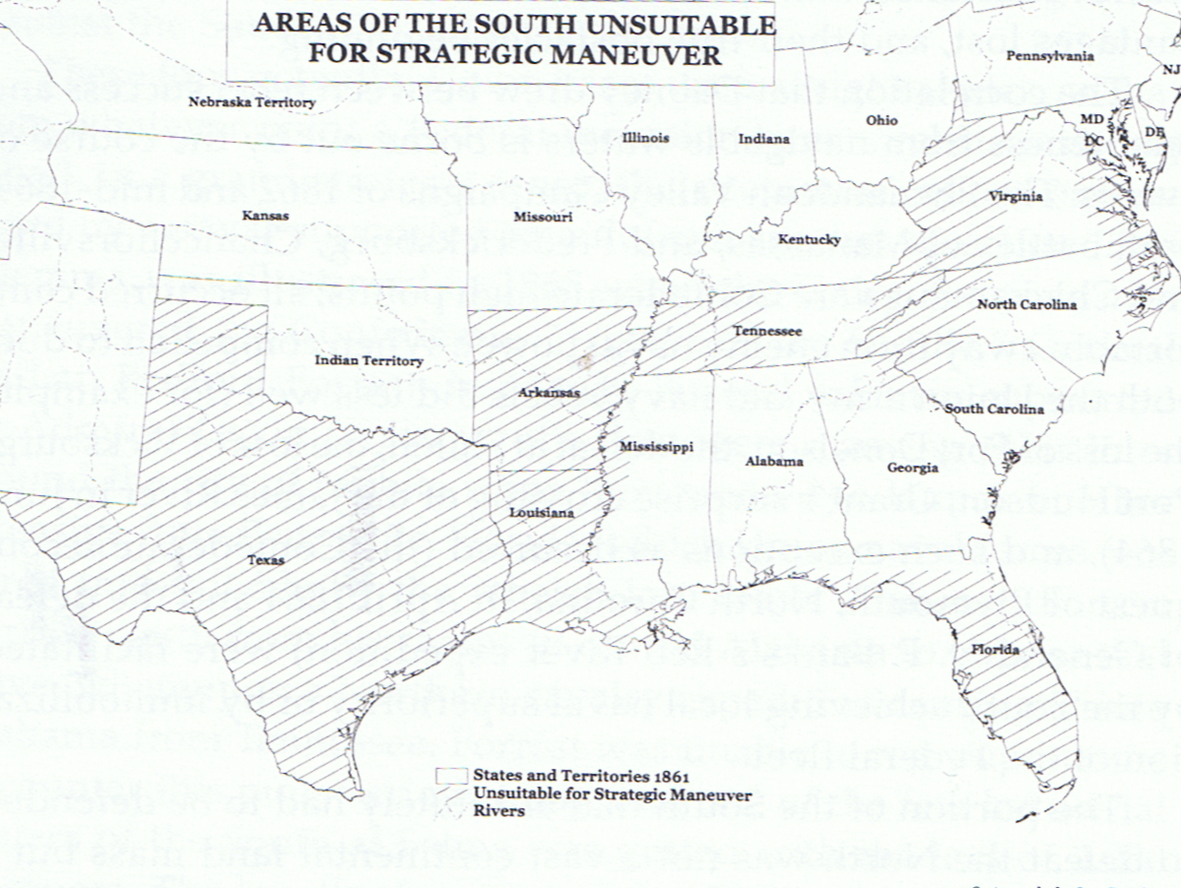

**The reasons for Virginia’s importance to the Confederacy.**

* Tredegar Iron Works was North America’s 2nd largest factory, and the only facility in the South capable of producing locomotives.
* Tredegar produced half of the CSA’s cannon.
* The Richmond Arsenal produced 40% of the CSA’s small rounds and artillery shells.
* Tredegar was one of only 2 facilities in the Confederacy to produce RR car axles. The other Etowah Iron Works in Georgia